Affiliation:
FAST-NUCES KARACHI Pakistan

Specialization:  Information Technology Artificial Intelligence |  |  | Department:  Computer Science and  Computer Information Systems Department, Faculty of Computing, and Information Technology
Domain Applied Research
Proposal Title: AI enabling approach using Deep learning for detecting abnormalities in CR-IoT

Desired Starting Date  1st October 2022 |  | Proposed Duration  (Max months)  12 Months |  |  | Required Budget  US dollars 41641
Nationality | Investigator’s Affiliation ( Dept. / College ) |  |  | Academic Title |  | Name of the Investigator(s)  (Full Name)
Pakistani | Computer Science Department FAST-NUCES Karachi Pakistan |  |  | Assistant Professor |  | Principal Investigator  Dr.Muhammad Farrukh Shahid
 |  |  |  |  |  | Co-Investigator
 |  |  |  |  |  | External Investigator
 |  |  |  |  |  | Co-Investigator
Signature of Principal Investigator

Abstract

The Cognitive Radio (CR) technology integrated with Internet of Things (IoT) devices has emerged as potential information technology by allowing efficient and large-scale deployment of IoT systems but the most addressed problem in this technology is that the Cognitive Radio Networks (CRN) are inclined to more attacks and are highly vulnerable as compared to the other traditional wireless networks. In this work, a CR-IoT network system model is proposed that comprises of a small tower, a few cognitive devices, and a jammer. To detect the abnormal signals, an AI-based deep learning model is proposed and developed to capture the trace of abnormal and suspicious activities in a network. The accuracy of the proposed system performance is analysed and assessed using area under the curve (AUC) and confusion matrices.
- We aim to develop an autonomous system for the medical application that detects and identifies abnormalities in a CR-IoT network. The proposed method will enhance overall network security by detecting abnormal activities launched by the jammer or unwanted entity which may cause cognitive devices in a network to receive wrong or modified information.

Keywords: Artificial Intelligence, Cognitive Radio, IoT, Medical, Deep Learning.

- Introduction

Information and communication technology (ICT) has evolved significantly due to the developments and advancements in network systems. These days’ users can avail various services and approach numerous applications on their mobile phones, revealing the perk of growth in the ICT field. Internet of Things (IoT) has emerged as a potential technology that aims to connect all the applications and fields to a single device or a network [1]. More specifically, it is a network comprising several objects to facilitate communication and exchange of information. Devices in a CR-IoT network is equipped with cognitive capabilities to execute intelligent decision and efficiently use spectrum and network resources and adding more comfort to the people life [2]. CR-IoT has revolutionized many fields such as transport, healthcare, education, tourism, and many more, and at the same time, it is contributing significantly to the grow the country's economy [3]. We can perceive IoT as a future technology due to its numerous advantages and benefits.
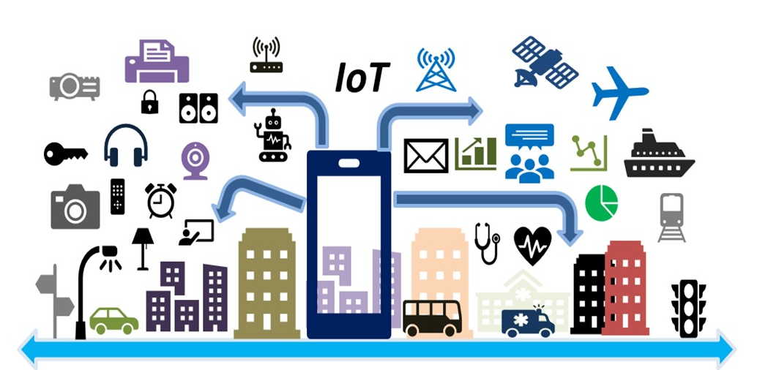
Figure. 01: CR-IoT- A network that connects everything to a single device

Figure.01 gives a global idea of IoT network [4]. In this research project, we take advantage of the IoT network equipped with cognitive capabilities and propose to develop IoT based automatic health monitoring system using Deep Learning (ML) and Probabilistic Bayesian models. We discuss the anatomy of the proposed system in section 4 (Refer Figure.02). Our proposed system comprises feature extraction which enable it to utilize for practical health related problems. The key features of the proposed system are highlighted by Figure.02 and are discussed in sequel. These features are generically required by the DL models which enables automatic IoT-based health monitoring systems:
1. Authenticated and secure health system for people.
2- Facilitate health monitoring and getting feedback from doctor online.
3- Abnormality detection mitigation by introducing self-aware (SA) in the devices of the IoT network for the medical system.
4-. Self-aware and self-configured IoT network to monitor health conditions of a patient.
- Literature Review

CR-IoT devices will be equipped with cognitive capabilities to deal with spectrum related issues [5]. In [6], author describes challenges and issues related to CR-IoT network. IoT opportunistic access via CR is presented in [7] for FM radio access. In [8 spectrum sensing for CR-IoT is presented which uses energy efficient dynamic algorithm. For CR-IoT network, efficient and enhanced resource allocation algorithm for real time traffic is formulated in [9].
CR is vulnerable to the various malicious signals. Hence detection of such kind of unwanted signals is still a challenging task. Several AI methods have been implemented to detect those signals which are quite different from normal signal in the CR network. In [10] authors demonstrated NN techniques to detect abnormal signals in the spectrum. Tandiya et al. [11] presented RF anomaly detection method in wireless network using deep predictive coding neural network. In [12] authors presented enhanced anomaly detection method based on deep neural networks. In [13] authors proposed neural network-based prediction model to analyze users’ activities and detect abnormal signals in the mobile communication network. Nawaz et al. [14] presented jammer detection approach using neural network. In [15] authors presented anomalies detection in spectrum using HMM approach. In [16] anomaly detection is discussed based on HMM. In [17] authors presented primary user detection in CR by using HMM. In [18], presented anomaly detection method based on genetic algorithm. Rajendran et al. [19] proposed an unsupervised method to detect abnormalities in wireless radio spectrum by exploiting absolute power spectral density (PSD) of the signal. The authors have proposed and presented anomaly detection method based on distributed framework for software defined IoT network [20] and in [21], deep generative model such as Generative Adversarial network (GAN) and Variational autoencoder (VAE) models for anomaly detection in CR-IoT network. In [22], edge assisted method is presented for abnormality detection in IoT network is described. Convolution neural network exploiting temporal features is deployed and implemented to detect anomalies in CR-IoT network is presented in [23]. Motivated by the various work presented by the researcher to detect abnormalities in a CR-IoT network, we propose to develop a framework using deep learning model to detect abnormalities in a CR-IoT network. The proposed method is novel because it incorporates the framework to introduce SA in the implementation of the model. The SA system learns the normal situation in an incremental process and captures abnormalities by observing the data values that deviate from the normal information.
- Description (Rationale) Of the Proposed Work
- In this work, we consider the problem of abnormality detection in the network equipped with sensors. Such a network is highly subjected to different kind of anomalies such as jammer attacks at the physical layer and other types of multiple abnormalities at different layers. In this project work, we consider jammer attacks at the physical layer of a network and propose a novel method to detect such threats in a network. Figure.02 shows a considered scenario for this work that contains cognitive devices (smartwatches, mobile phones), a base station (BS), a central processing unit (CCU), and a smart jammer.
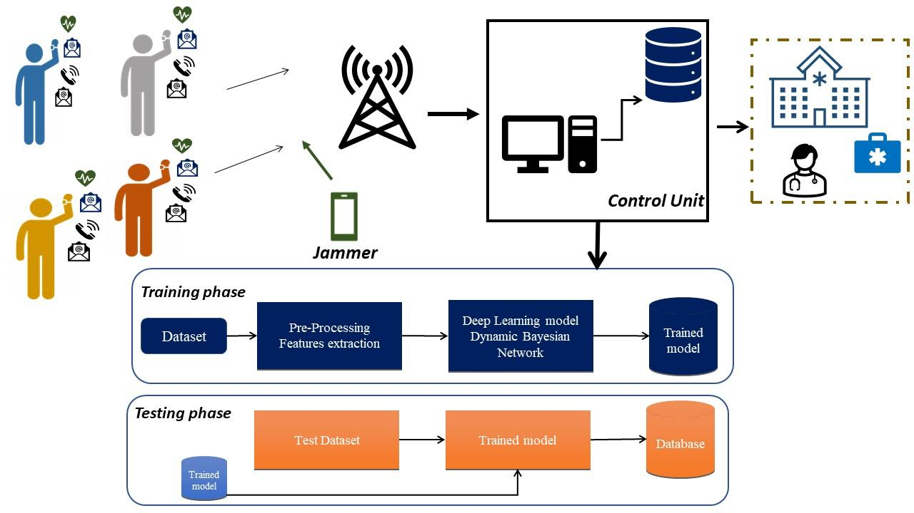
- Fig.02 Considered scenario for the proposed work

- Cognitive devices are assumed to communicate with the BS and send information using Orthogonal Frequency Division Multiplexing (OFDM) modulated signal transmission. OFDM is a vital choice for signal transmission in many popular wireless technologies such as Wi-Fi, LTE, and 5G mobile networks. A jammer disrupts the communication of the cognitive devices with the BS by launching its attacks on signals. Consequently, a doctor may receive wrong health information due to such kinds of attacks in a network by the jammer. Therefore, it is essential to detect malicious signals in a network to avoid receiving the wrong information. For example, a person sends his abnormal health information due to a heart problem to the doctor by using a communication link of a network. The jammer attacks that signal and makes it normal, and the doctor receives regular health information while the patient needs immediate treatment from the doctor. That is why it is imperative to make the entire network more secure against such attacks. There has been a lot of research carried out to detect network anomalies which contain machine learning, deep learning, and other signal processing techniques. Our method exploits deep learning and probabilistic graphical models in a joint framework to capture abnormalities in a network. Moreover, our approach will facilitate incorporating Self-awareness (SA) in a system to realize AI-enabled communication CR-IoT network. Fig. 3 describes the process to incorporate and introduce SA into the developed framework. The model should be able to learn from normal situations and detect any abnormalities that occur in the network.
- 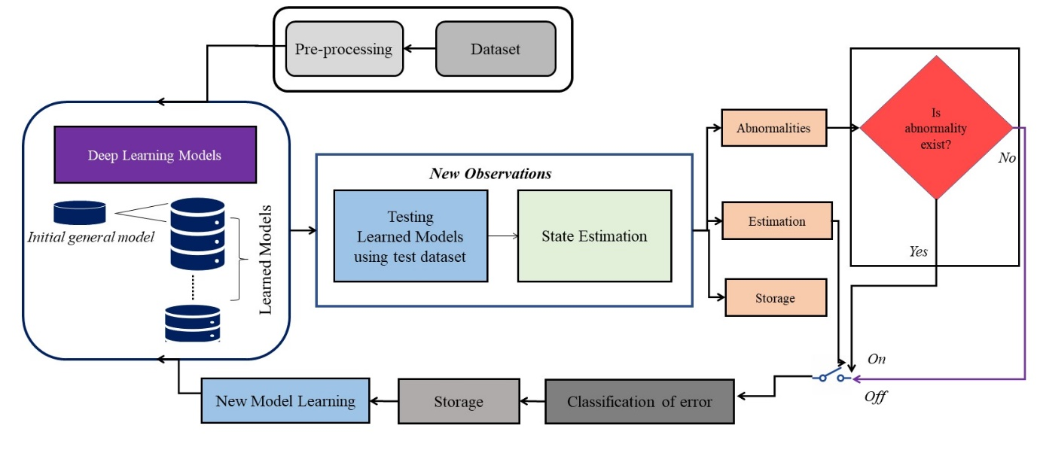
- Fig.03 Introducing SA into the proposed method

- Research Objectives
The main objective of this research project is to build and develop techniques for autonomous detection of abnormalities in a CR-IoT network deployed for a health care application. The main objectives are as follows.
- Develop a method to detect abnormalities (jammer attacks) in a CR-IoT network.
- Autonomously learn the normal and abnormal situation in the network and take decisions in incremental fashion to avoid abnormalities.
- Validating and testing the developed AI model for different scenarios in a CR-IoT network.
- Develop a product that exhibits Self-Awareness and able to detect abnormalities.
- Develop a self-aware model that can detect abnormalities and communicate immediately to the concern entity about the abnormal situation so that precaution measure can be taken on a time.
The tables 4.1 and 4.2 maps the objectives, approaches, phases, and the tasks carried out to implement the objectives.
Table 4.1 OBJECTIVES AND THEIR APPROACH MAPPING
Objective | Approach for achieving the objective
1 | Build an autonomous model to identify and detect abnormalities in a CR-IoT network
2 | Set-up an experimental environment by deploying different cognitive devices (sensors) connected with a central control unit and collect a dataset.
3 | Simulate the considered scenario by performing different experiments considering various transmission parameters. After that, extract features from the signals and form a state vector. Divide the dataset in training, validating, and testing dataset.
4 | Applying dataset to train the DL model.
5 | Validate and test the model using validate and test sets.
6 | Perform evaluation using accuracy, precision and recall of the system
7 | Transform the developed model into the product and perform analysis. Moreover, develop a mobile application of the model.
8 | Hire graduate and undergraduate students from the college to promote a culture of research and carry out the research in cognitive radio, IoT and AI domains.

- Table 4.2 OBJECTIVE PHASES AND TASKS MAPPING
Objectives | Phases | Tasks
1 | Comprehensive literature survey | Perform a comprehensive literature survey to further develop strong intuition about the state-of-the-art research methods in abnormality detection in the CR-IoT network.
2, 3 & 7 | Data Collection | - Develop and build an experimental setup in the university lab.  - Deploying different cognitive sensors and central control unit (CCU) in the considered environment.  - Consider the OFDM modulated transmission between devices and CCU and collect the received signals at the receiving terminal of the cognitive devices.
4, 5 & 7 | Feature extraction and Deep Learning Model | - Extract the features from the received signals. We extract amplitude and phase information from the signal.  - Form a state vector containing amplitude and phase information and their first order derivative.  - Train the deep learning model by giving a state vector as an input.
4 | Model Tuning | Train the model by considering different hyper parameters. Avoid model overfitting and underfitting issues by doing training several times.
5 & 6 | Evaluation | Validate and test the model and check the performance using AUC curves and confusion matrix.
7 & 8 | Develop a Product and mobile application and write-up | 1. Transform the model into the product and developed mobile application.  2. Write project progress reports  3. Publish work in conferences and/or journals

- Scope
- The project's scope is not limited to only specific applications. Still, it can also be extended to other fields such as autonomous vehicle navigations, smart agriculture, transport, education, and many more. The project gives intuition to develop a self-aware and cognitive system for detecting abnormalities in an IoT-oriented network. Incremental learning will also be demonstrated, and it's a realization for AI-enabled CR-IoT network.
- Development of the self-aware IoT based health monitoring system.
- Abnormalities detection and mitigation in the health care system to provide more secure and enhance services to the patients.
- Integrated and customized solution health care device for the people of the country.

6. Research Design

Our approach to addressing the aforementioned challenges will consist of two phases. The dataset will be collected in phase one by setting up an experimental environment. After dataset collection, features of the signal will be extracted. We will use OFDM modulated signal to extract amplitude and phase information. We will then deploy a deep learning model to train on a given dataset and then test the model in the second phase.
The project will consist of the following phases:

6.1.1 Phase 1: Comprehensive Literature Review
We will conduct a comprehensive literature survey from multiple resources and determine the state-of-the-art technique present in the literature. We will study the different types of jammer present in a network. We will explore other deep learning models deployed for abnormality detection in a network.
6.1.2 Phase 2: Data Collection
We will set up an experimental environment in one of our university labs to collect a dataset by performing several experiments. We aim to collect our dataset, which will be a significant challenge in our work.
6.1.3 Phase 3: Data-pre-processing (Feature Extraction)
After dataset collection, we will extract features (amplitude and phase) from the signal and form the generalized state vector. The state vector will consist of the amplitude and phase information of the received signals.
6.1.4 Phase 4: Deep learning model and Probabilistic graphical model
We will deploy VAE, one of the powerful DL models, to transform higher dimension data into low dimension data. VAE provides a facility to extract complicated features from the high dimension data and convert them into compact latent dimensions. After obtaining information in the form of latent dimension, we will perform state estimation by using a Dynamic Bayesian network (DBN). DBN facilitates inference of a network and eventually detects abnormalities in a network.
6.1.5 Phase 5: Evaluation
We will evaluate the model by using AUC curves and confusion matrices. We will plot some abnormal curves to analyze the performance of a model.
6.1.6 Phase 6: Tool Development
We plan to develop mobile application that give the health information and the intimate about the abnormalities that occur during transmission and mitigate the effects by using developed method in this project.
6.1.7 Phase 7: Writing-up and documentation

We plan to write a journal article, conference paper and book chapter of this innovative work to make it scientific valuable.

- Research Methodology

7.1 Methodology
As discussed in the preceding section, we will use deep learning and probabilistic models for anomalies detection. We have described the previous section’s approach, task, and phases. Here, we aim to discuss experimental setup, deep learning model (training and testing phases), evaluation criteria. This section will also highlight the proposed incremental learning block diagram to bring SA into the CR-IoT network.

7.1.1 Data Collection
We will organize an experimental setup in the research lab at our university. We aim to deploy several cognitive devices and conduct OFDM signal transmission. We will consider IEEE802.11 ah OFDM modulation parameters.

7.1.2 Feature Extraction
We will extract features such as amplitude and phase information from the received signal and form a generalized state vector. The OFDM signal can be considered a time-frequency grid containing time and frequency information, as shown in Fig.03 The generalized state vector will contain amplitude and phase information. OFDM includes an inherited FFT block in its receiver architecture; hence we can readily obtain amplitude and phase information from the FFT block. Moreover, we don’t need to use another transformation technique such as wavelet transform, STFT transform as OFDM contains FFT block already in its reverse architecture.

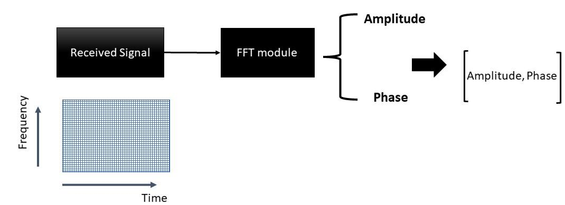
Figure.03 FFT information extraction from the received signal

7.1.3 Deep learning model and DBN
We will deploy a Variation AutoEncoder (VAE) to transform the signal into the low dimension data, and afterward, we implement DBN to perform inference tasks. DBN facilitates capturing abnormalities on the latent dimension data obtained from VAE. It also allows predicting the future state of signals evolving with time.
7.1.4 Evaluation
We will apply test data containing abnormalities to the trained model and assess the performance by plotting ROC curves and confusion matrices. Moreover, we aim to plot several abnormality signals which will show anomalies in the spectrum.

- Management & Working Plans with Team Roles

8.1 Management Plan, Research Team, Roles, and Tasks
The work in this project will be conducted by a team of three investigators. They will meet twice a week to discuss the progress of the project and to exchange information about the tasks. Being faculty members of the FAST NUCES Karachi and faculty of computing and information technology of King Abdul-Aziz University (KAU), the investigators intend to advise some of their students to participate in the project. It is estimated that 5 selective research assistants will be needed to help the investigators in developing the overall system. All the investigators are experienced in their respective areas.
The expected duration of this project is 12 calendar months. All investigators (PI and two Co-I) will be involved in all stages of the project and will work for two years during non-vacation, and PI will work for a month of vacation time. PI will spend the vacation periods reviewing and assessing the accomplished work up to that point.
A progress report will be submitted every six calendar months. The second progress report will be submitted at the end of the first year and it will be a detailed one. However, the first and the third progress reports are going to be short ones as summary reports to briefly explain the major findings of the respected period. The final report will be submitted by the end of the research, and it will present all details of the project.
Research papers are expected to be presented in international conferences as well as local ones. At least, two technical papers are expected to be published out of this project. The full papers will be included in the final report as appendices of the report.
Table 8.1 and 8.2 introduce and details the research team, their roles, tasks carried out by the team members and their timelines.
Table 8.1 ROLE AND INVOLVEMENT DURATION OF RESEARCH TEAM

Team Members | Role | Duration  (months)
Senior Personnel: | We intend to carry out this project as a mini-research group, in which each member is expected to be involved in literature review, model/tool building and testing, write-up | 10 – 12
Dr.Muhammad Farrukh Shahid (MFS) | Dr. Muhammad Farrukh Shahid is a Principal Investigator who will be responsible for overall research project, both in the management of its activities and tasks as well as ensuring the consistency of how its various scientific parts (IoT and machine learning aspects) fit together. He will specifically be responsible for ensuring phases 2 and 3 of the project (data collection and feature extraction) are valid according to the scientific principles of the context so that our deep-learning models are properly contextualized. | 10 – 12
Prof. Dr. Tariq Jamil Saifullah Khanzada (TK)  Other Personnel: | Prof. Tariq J.S. Khanzada (TJ) Prof. Tariq J.S. Khanzada (TJ) is a professor and will be working as consultant to the project. He will be responsible for developing for the IoT security algorithms that will employ the machine-learning models developed by other members, and in collaboration with his students, in developing the hardware and software tools that will deploy these algorithms. This pertains mainly to phase 5 and 6 (evaluation and tool development) | 10 – 12
Master Student (MS) (01) and 3 Undergraduate students (UGS) | One MS along with the team of 3 undergraduate students will be implementing the models and methods for educational bot development. The model implementation using Python (Jupyter Notebook, Tensor Flow) and MATLAB 2020 will be used as a Software tool | 8
Programmers and Devlopers (P&D) (02) | The programmers are required to expedite the work and incur the programming and designing tasks.  We will be deploying various sensors to record and monitor health related information. Initially, we will set sensor at a static random selected locations to avoid any channel variations. | 9
Technician (Te) | Technician services will be required to set over all working environment and networking services for conducting and implementing the research tasks, and for deploying the sensors by changing location of the sensors. | 8-4

Table 8.2 PROJECT TIMELINE MAPPED WITH THE TEAM ROLES AND PHASES

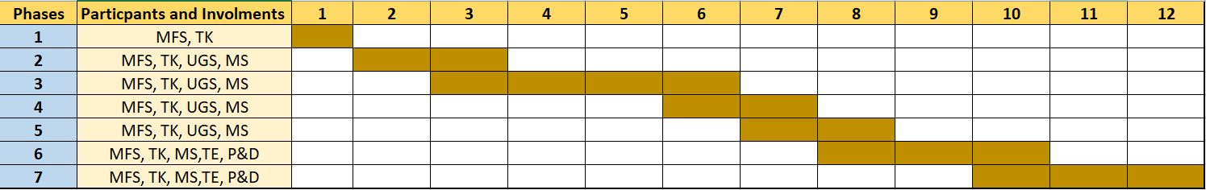

8.2 Project Outcomes and deliverables
This research project improves and enhances overall security of a CR-IoT network. The proposed method helps to make the entire network more robust against malicious attacks. We anticipate that this project will help to avoid unforeseen conditions and safe patient lives in emergency situations. The expected outcomes are as follows:
- AI-Based model for abnormality detection in a CR-IoT network.
- Self-aware devices network that learns the environment continuously and detect if any abnormal situation occurs in an incremental way.

Table 8.3 maps the project outcomes with the strategic technology goals

Table 8.3 RELATIONSHIP TO STRATEGIC FRAMEWORK

PROJECT  EXPECTED  OUTCOMES | STRATEGIC TECHNOLOGY PROGRAM GOALS |  |  | PROJECT  OBJECTIVE  ACHIEVED
PROJECT  EXPECTED  OUTCOMES | GOAL 1  Advances in AI/Deep learning research | GOAL 2  Abnormality detection in CR-IoT network | GOAL3  Developing Self-aware system | PROJECT  OBJECTIVE  ACHIEVED
1 (Original research) | √ |  |  | 7 & 8
2 (AI-enable system for abnormality detection) |  | √ | √ | 1, 3, 5 & 6
3 (SA to learn normal and abnormally situation) |  | √ | √ | 2 & 4

9. Utilization

- The expected results will be quite intimidating and promising to detect and capture anomalies which may lead to conclude wrong decision conceived by the CR-IoT network.
- The results will facilitate in building up entirely autonomous system based on CR-IoT network.
- The research work will be benefitting the university students to adopt and experience the promising technologies.
- It will enhance the capabilities of the university students as well as teaching staff to participate in international research projects.
- The project will also improve the research publication production amongst the students.
- The social economic culture will be improved as an outcome of this project.
- It will meet the vision 2030 objective by enhancing the economy of the kingdom.

10.Curriculum Vitae (of each research team member)

The CVs of all team members are included in separate file.

11. Project Budget
Table 11.1 shows the proposed budget of the project and table 11.2 provides the justifications of the budget. We have divided the project into two phases, first half and second half.

Table 1`.1 PROPOSED BUDGET
: |  | SUMMARY  PROPOSED BUDGET |  |  |  |  |  |  | Dollars ($)
PROJECT TITLE |  | AI enabling approach using Deep learning for detecting abnormalities in CR-IoT
DURATION |  | (12) MONTHS
ITEM | CATEGORY | NO. | COMPENSATION |  |  | FIRST HALF |  | SECOND HALF |  |  | TOTAL
 |  |  |  |  |  | MONTHS | BUDGET | MONTHS |  | BUDGET | TOTAL
A-Research Team | CONSULTANTS
A-Research Team | PRINCIPAL INVESTIGATOR | 1 | 2794 |  |  |  |  |  |  |  | 2794
A-Research Team | CO-INVESTIGATOR-2 | 1 | 2394 |  |  |  |  |  |  |  | 2394
 |  |  |  |  |  |  |  | TOTAL-A |  |  | 5,188
B- Assistants | PHD STUDENTS
B- Assistants | MS STUDENTS | 1 | 213 |  |  | 4 |  | 4 |  |  | 1704
B- Assistants | UNDERGRADUATE STUDENTS | 3 | 160 |  |  | 4 |  | 4 |  |  | 3840
B- Assistants | TECHNICIANS | 1 | 106 |  |  | 4 |  |  |  |  | 424
B- Assistants | SECRETARIAL- CLERICAL
B- Assistants | OTHER (programmers and developers) | 2 | 106 |  |  | 6 |  | 6 |  |  | 636
 |  |  |  |  |  |  |  | TOTAL-B |  |  | 11,792
C- Computer Services & Consultants | Computer Service (Connection and telecommnication costs) |  | 1915 |  |  | Internet connection and communicatin needs |  |  |  |  | 1915
C- Computer Services & Consultants | CONSULTANT | 1 | 1863 |  |  |  |  |  |  |  | 1863
 | Consultant Services
 |  |  |  |  |  |  |  | TOTAL-C |  |  | 3778
D- EQUIP.  & MATERIAL | MAJOR EQUIPMENTS (< = 100.000)
D- EQUIP.  & MATERIAL | EQUIPMENTS Major (> 100,000)  Laptop/Mac, 4 High GPU and CPU for Deep Learning (MacBook Pro 14" with 16core GPU, RAM 32, Proc i9) |  |  |  |  | 14366 |  | To train deep learning algorithm, Bayesian Network and design UI |  |  | 14366
D- EQUIP.  & MATERIAL | EQUIPMENTS Minor (> 10,000)  Sensors, sensor modules small base station, Lora WAN cloud server and smartphone for testing requirement  20 to 30 sensors,1 Android high end phone, 1 LoRA WAN module, 10 Sensor modules |  |  |  |  | 1995 |  | Different sensors, base station, WAN to set-up experimental environment and gather data. Mobile phone to test the model for the mobile app development. |  |  | 1995
 | CONFERENCES |  |  |  |  | 2x133 |  |  |  |  | 266
 | PATENT REGISTRATION
 | PUBLICATIONS |  |  |  |  | 2x2128 |  |  |  |  | 4256
 | WORKSHOP |  |  |  |  | -
 | OTHER EXPENSES
ITEM TOTAL |  |  |  |  |  |  |  |  |  |  | 20883
GRAND TOTAL
A. SALARIES (Research Team) |  |  |  | 12.45% | 5188
B. SALARIES (Assistants) |  |  |  | 28.32% | 11792
C. Computer Services & Consultants |  |  |  | 9.08% | 3778
D. EQUIP. & MATERIAL |  |  |  | 50.15% | 20883
GRAND TOTAL |  |  |  | 100 % | 41641

REFERENCES

- H. Tran-Dang, N. Krommenacker, P. Charpentier and D. Kim, ”Toward
the Internet of Things for Physical Internet: Perspectives and Challenges,”
in IEEE Internet of Things Journal, vol. 7, no. 6, pp. 4711-4736, June 2020,
doi: 10.1109/JIOT.2020.2971736Amazon.com: Statistically improbable phrases. Retrieved February 13, 2011, from http://www.amazon.com/gp/search-inside/sipshelp.html.
- F. Meneghello, M. Calore, D. Zucchetto, M. Polese and A. Zanella, ”IoT:
Internet of Threats? A Survey of Practical Security Vulnerabilities in Real
IoT Devices,” in IEEE Internet of Things Journal, vol. 6, no. 5, pp. 8182-
8201, Oct. 2019, doi: 10.1109/JIOT.2019.2935189.
- J. Huang, Y. Meng, X. Gong, Y. Liu and Q. Duan, ”A Novel Deployment
Scheme for Green Internet of Things,” in IEEE Internet of Things Journal,
vol. 1, no. 2, pp. 196-205, April 2014, doi: 10.1109/JIOT.2014.2301819
- F. Montori, L. Bedogni and L. Bononi, ”A Collaborative Internet of Things
Architecture for Smart Cities and Environmental Monitoring,” in IEEE
Internet of Things Journal, vol. 5, no. 2, pp. 592-605, April 2018, doi:
10.1109/JIOT.2017.
- A. Aijaz and A. H. Aghvami, “Cognitive machine-to-machine communications for internet-of-things: A protocol stack perspective,” IEEE Internet of Things Journal, vol. 2, no. 2, pp. 103–112, April 2015.
- S. Chatterjee, R. Mukherjee, S. Ghosh, D. Ghosh, S. Ghosh, and A. Mukherjee, “Internet of things and cognitive radio — issues and challenges,” in 2017 4th International Conference on Opto-Electronics and Applied Optics (Optronix), Nov 2017, pp. 1–2.
- D. T. Otermat, C. E. Otero, and I. Kostanic, “Analysis of the fm radio spectrum for internet of things opportunistic access via cognitive radio,” in 2015 IEEE 2nd World Forum on Internet of Things (WF-IoT), Dec 2015, pp. 166–171.
- J. Adu Ansere, G. Han, H. Wang, C. Choi, and C. Wu, “A reliable energy efficient dynamic spectrum sensing for cognitive radio iot networks,” IEEE Internet of Things Journal, vol. 6, no. 4, pp. 6748–6759, Aug 2019Konchady, M. (2008). Buiding search applications: Lucene, LingPipe, and Gate (1st Edition ed.). Mustru Publishing.
- F. Khan, A. U. Rehman, M. A. Jan, and I. U. Rahman, “Efficient resource allocation for real time traffic in cognitive radio internet of things,” in 2019 International Conference on Internet of Things (iThings) and IEEE Green Computing and Communications (GreenCom) and IEEE Cyber, Physical and Social Computing (CPSCom) and IEEE Smart Data (SmartData), July 2019, pp. 1143–1147.
- Y. Sani, A. Mohamedou, K. Ali, A. Farjamfar, M. Azman, and S. Shamsuddin, “An overview of neural networks use in anomaly intrusion detection systems,” in 2009 IEEE Student Conference on Research and Development (SCOReD), Nov 2009, pp. 89–92.
- N. Tandiya, A. Jauhar, V. Marojevic, and J. H. Reed, “Deep predictive coding neural network for rf anomaly detection in wireless networks,” in 2018 IEEE International Conference on Communications Workshops (ICC Workshops), May 2018, pp. 1–6.
- S. Naseer, Y. Saleem, S. Khalid, M. K. Bashir, J. Han, M. M. Iqbal, and K. Han, “Enhanced network anomaly detection based on deep neural networks,” IEEE Access, vol. 6, pp. 48 231–48 246, 2018.
- M. S. Parwez, D. B. Rawat, and M. Garuba, “Big data analytics for user-activity analysis and user-anomaly detection in mobile wireless network,” IEEE Transactions on Industrial Informatics, vol. 13, no. 4, pp. 2058–2065, Aug 2017.
- T. Nawaz, D. Campo, M. O. Mughal, L. Marcenaro, and C. S. Regazzoni, “Jammer detection algorithm for wide-band radios using spectral correlation and neural networks,” in 2017 13th International Wireless Communications and Mobile Computing Conference (IWCMC), June 2017, pp. 246–251.
- W. Honghao, J. Yunfeng, and W. Lei, “Spectrum anomalies autonomous detection in cognitive radio using hidden markov models,” in 2015 IEEE Advanced Information Technology, Electronic and Automation Control Conference (IAEAC), Dec 2015, pp. 388–392.
- F. Wang, H. Zhu, B. Tian, Y. Xin, X. Niu, and Y. Yang, “A hmm-based method for anomaly detection,” in 2011 4th IEEE International Conference on Broadband Network and Multimedia Technology, Oct 2011, pp. 276–280.
- A. M. Mikaeil, B. Guo, X. Bai, and Z. Wang, “Hidden markov and markov switching model for primary user channel state prediction in cognitive radio,” in The 2014 2nd International Conference on Systems and Informatics (ICSAI 2014), Nov 2014, pp. 854–859.
- Q. Su and J. Liu, “A network anomaly detection method based on genetic algorithm,” in 2017 4th International Conference on Systems and Informatics (ICSAI), Nov 2017, pp. 1029–1034.
- S. Rajendran, W. Meert, V. Lenders, and S. Pollin, “Unsupervised wireless spectrum anomaly detection with interpretable features,” IEEE Transactions on Cognitive Communications and Networking, vol. 5, no. 3, pp. 637–647, Sep. 2019.
- R. Kiani and A. Bohlooli, "Distributed Rule Anomaly Detection in SDN-based IoT," 2021 5th International Conference on Internet of Things and Applications (IoT), 2021, pp. 1-6, doi: 10.1109/IoT52625.2021.9469714.
- T. Zixu, K. S. K. Liyanage and M. Gurusamy, "Generative Adversarial Network and Auto Encoder based Anomaly Detection in Distributed IoT Networks," GLOBECOM 2020 - 2020 IEEE Global Communications Conference, 2020, pp. 1-7, doi: 10.1109/GLOBECOM42002.2020.9348244.
- T. Zixu, K. S. K. Liyanage and M. Gurusamy, "Generative Adversarial Network and Auto Encoder based Anomaly Detection in Distributed IoT Networks," GLOBECOM 2020 - 2020 IEEE Global Communications Conference, 2020, pp. 1-7, doi: 10.1109/GLOBECOM42002.2020.9348244.
- Y. Cheng, Y. Xu, H. Zhong and Y. Liu, "Leveraging Semisupervised Hierarchical Stacking Temporal Convolutional Network for Anomaly Detection in IoT Communication," in IEEE Internet of Things Journal, vol. 8, no. 1, pp. 144-155, 1 Jan.1, 2021, doi: 10.1109/JIOT.2020.3000771.

